Завдання 4.

Your favorite bicycle daily rental store has just introduced a new Customer Relationship Management system and asked you, one of their most loyal members, to test it.

The implemented features are as follows:

* Anyone can rent a bicycle, but members receive a 20% discount
* However, if the return deadline is missed, the discount is no longer available
* After 15 rentals, members get a gift: a T-Shirt

Decision table describing the implemented features looks as follows (see the decision table in attachment here: 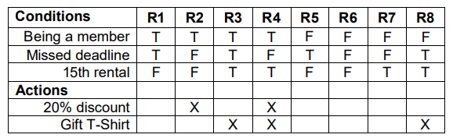

:one: Умови завдання:

Based ONLY on the feature description of the Customer Relationship Management system, which of the above rules describes an impossible situation?

Choose the right (one) option and explain your choice:

a) R4 b) R2 c) R6 d) R8

**Explanation:**

1. R4 - possible situation. Customer is a member; No missed deadline; 15th rental done; Actions: 20% discount - got; Gift T-Shirt - got.
2. R2 - possible situation. Customer is a member; No missed deadline; 15th rental - No; Actions: 20% discount - got; Gift T-Shirt - No.
3. R6 - possible situation. Customer is not a member; No missed deadline; 15th rental - No; Actions: 20% discount - No; Gift T-Shirt - No.
4. R8 - impossible situation. Customer is not a member; Customer missed deadline; 15th rental done; Actions: 20% discount - No (because not a member and missed deadline); Gift T-Shirt - No (15th rentals done, but **not a member**).

**Answer:**

d) R8 - is impossible situation.